Roll No: 241901505
Name: Krishna Kumar J
Experiment: 12

LEARNING AND ASSIGNMENT OF IP ADDRESS MANUALLY TO
COMPUTERS

AIM:
To learn how to assign IP addresses manually to computers in a network using Cisco Packet Tracer.

ALGORITHM:
- Open Cisco Packet Tracer.
- Create a simple network by connecting two or more PCs with a switch.
- Select a PC, click on it, and open the Desktop tab.
- Click on IP Configuration.
- Manually enter:
  - IP Address (e.g., 192.168.1.2)
  - Subnet Mask (e.g., 255.255.255.0)
  - Default Gateway (if required, e.g., 192.168.1.1)
- Repeat the process for all other PCs (assign different IPs in the same network).
- Test connectivity using the ping command from one PC to another.
- Observe the results and save the configuration.
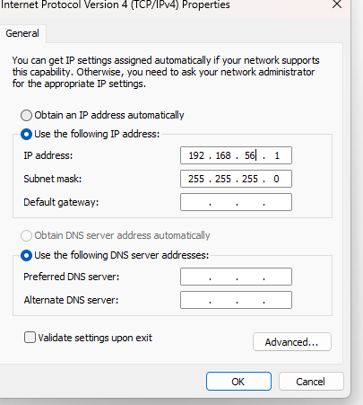

OUTPUT:
BEFORE CHANGING
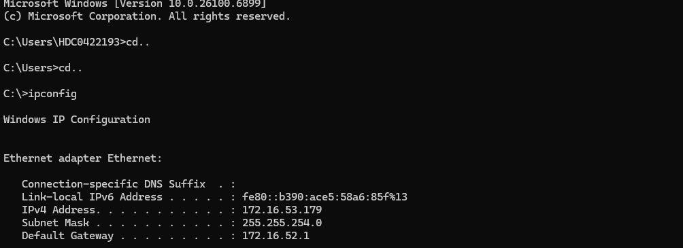

AFTER CHANGING
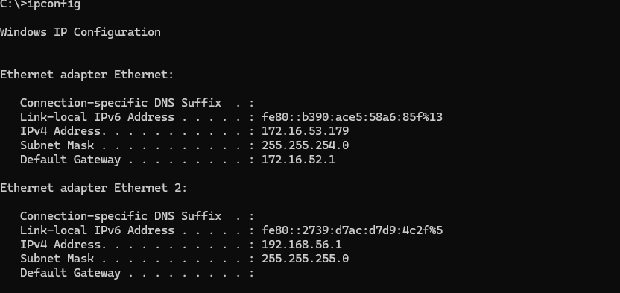

RESULT:
Thus, the system was configured and assigned an IP address manually to the system.

